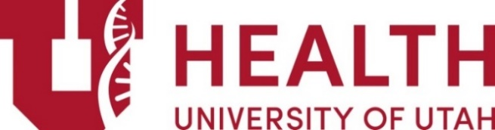

Dermatology Journal Club
Event Code: 41158

Friday, February 10, 2023
9:00 am – 10:00 am / Remote Meeting
“Morphologic review of the 2022 literature”
Moderated by: Lauren Madigan, MD

Image Review

Disclosure: Neither planners, speakers, or anyone in control of content have any relevant financial relationships with an ACCME-defined ineligible company to disclose or mitigate.

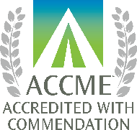
ACCREDITATION: The University of Utah School of Medicine is accredited by the Accreditation Council for Continuing Medical Education (ACCME) to provide continuing medical education for physicians.
AMA Credit: The University of Utah School of Medicine designates this live activity for a maximum of 1.0 AMA PRA Category 1 Credit(s) TM.
Physicians should claim only the credit commensurate with the extent of their participation in the activity. All attendees are encouraged to use the CME system to claim their attendance. Physicians will be awarded AMA PRA Category 1 Credit(s)™; all other professions will be awarded attendance at a CME event credit that they may use for their re‐credentialing purposes. All users will be able to print or save certificates. For questions regarding the CME system, please contact the UUCME Office. For questions regarding re‐credentialing process or requirements, please contact your re-credentialing organization.
NONDISCRIMINATION AND DISABILITY ACCOMMODATION STATEMENT: The University of Utah does not exclude, deny benefits to or otherwise discriminate against any person on the basis of race, color, national origin, sex, disability, age, veteran’s status, religion, gender identity, gender expression, genetic information, or sexual orientation in admission to or participation in its programs and activities. Reasonable accommodations will be provided to qualified individuals with disabilities upon request, with reasonable notice. Requests for accommodations or inquiries or complaints about University nondiscrimination and disability/access policies may be directed to the Director, OEO/AA, Title IX/Section 504/ADA Coordinator, 201 S President’s Circle, RM 135, Salt Lake City, UT 84112, 801-581-8365 (Voice/TTY), 801-585-5746 (Fax).

Next Dermatology Journal Club: March 10, 2023 (8:30 am)N

